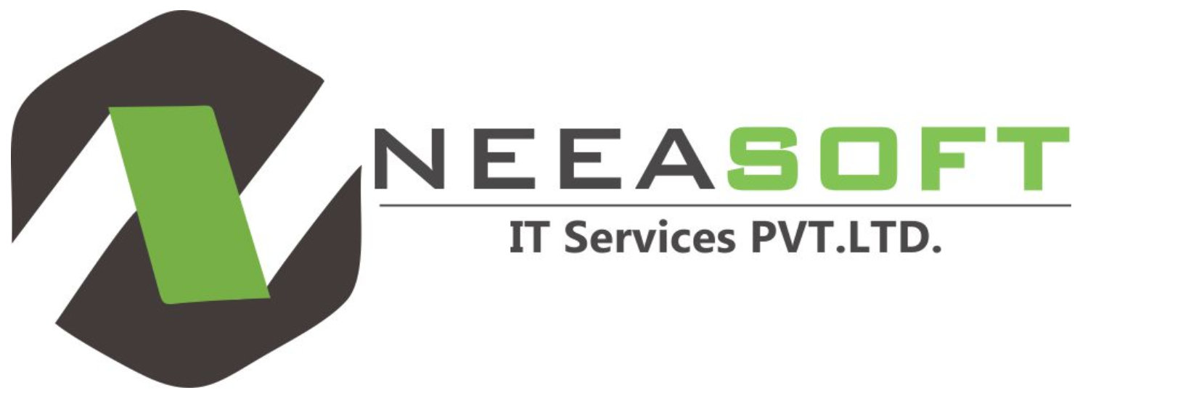

Neeasoft IT Services Pvt. Ltd is a company providing professional-level software development, website development, web designing, application development, digital marketing. They have website programmer for web design, manage, build and maintain high quality solutions for a wide range of businesses.

They have built business by working with clients to ensure the solutions they develop are profitable for them. Their forte is to take the software development, website development requirement, apply the understanding of web and software development methodologies and propose innovative & technical features and site enhancements that helps achieve goals - while taking into account commercial considerations & timeframe with high level of communication and support. Businesses as well as users have become more dynamic and reactive in their thinking because of the website, they expect to see up to date information immediately and in very proper manner. By choosing Neeasoft IT Services Pvt. Ltd website development services, you get more than our software programming, design and development work.

You also get our years of experience and expertise, in developing a Web site or Application unique to your business needs for PHP website development. Neeasoft IT Services Pvt. Ltd is an innovative technology industry focused, business driven professional custom PHP website development services firm. From web design and PHP web application development to custom applications, our talented developer work intelligently to solve and manage client’s needs and requirements. We custom PHP website development serves to deliver cost effective interactive technology and design solutions without compromising on quality. With clients globally, custom PHP website developer’s produces innovative, high-performance Web sites for companies in multiple industries including hospitality, retail, wholesale, communication and so on. Using the latest programming and design, Neeasoft IT Services Pvt. Ltd creates the optimal, effective online as well as desktop experience for every client. Custom website development can work within your existing corporate ID or create one for you to establish a sense of branding for your need. The quality of custom website development, designs and programming is evident in the Web sites and web applications we create. Our commitment to quality designs, superior technology enhancement and customer service is paramount.

Satisfying the client is fundamental to our business and has been the leading factor in our growth. We make ourselves available to our clients 24 x 7 for advising, training and assistance on all their PHP website development services related needs. Our Commitment we takes pride in our on time delivery and ability to meet quick turnaround requests while exceeding customer quality demands. Customer Satisfaction continues to be of utmost importance, as do Consistent quality, Constant innovation, Technology enhancement, Process improvement and Customer orientation.